# Objective

To download and install the necessary software so the Microsoft Kinect will work with Processing.

# Instructions

**Note: These instructions were created after installing the OpenNI framework on a 32-bit Windows 7 machine. While there are other .zip files on the following link, they have not been tested by this author at this point. **

1. Go to <http://code.google.com/p/simple-openni/downloads/list>
2. Download the proper OpenNI_NITE_Installer zip file for your system.
3. Download the SimpleOpenNI-0.26.zip file. This is the library for Processing.
4. Unzip the OpenNI_NITE_Installer folder and run the four installation folders in the following order (not in alphabetic order as the folder lists)  
   1. openni-win32-1.5.2.23-dev.msi
   2. SensorKinect091-Bin-Win32-v5.1.0.25.msi
   3. sensor-win32-5.1.0.41.redist.msi
   4. nite-win32-1.5.2.21-msi
5. Unzip the SimpleOpenNI-0.26.zip file. It contains the folder SimpleOpenNI. This folder needs to be copied into the proper Processing library folder. Here’s how:  
   1. Open Processing and go to “Preferences” (File->Preferences):

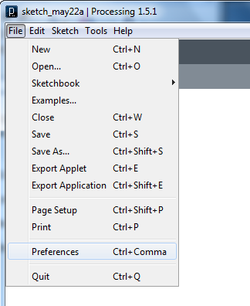

* 1. At the top, you will find the Sketchbook location path for your Processing program. Go to this directory on your computer:

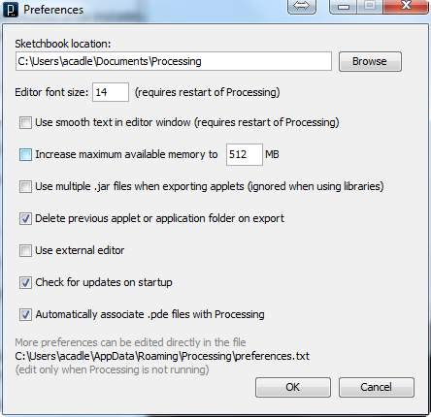

* 1. Add a folder called “libraries” if there is NOT already a folder with that name in your processing directory.

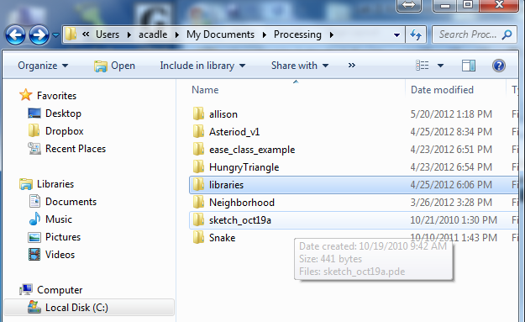

* 1. Put the unzipped SimpleOpenNI folder into the “libraries” folder.
  2. If you have done it correctly you should be able to open Processing, go to Examples:

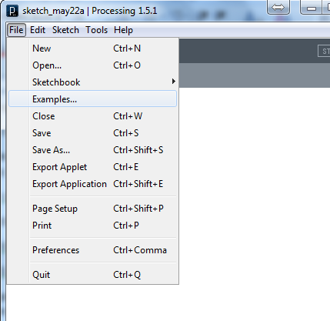

* 1. At the bottom of the examples list you should see a folder called SimpleOpenNI. 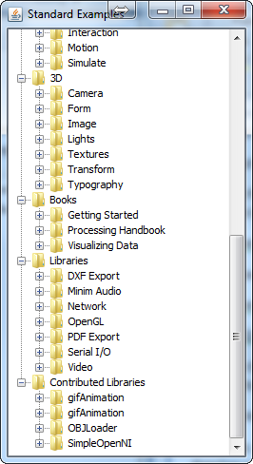

1. Reset your machine so that the new changes take effect.
2. Go back to the Processing examples folder and open up a SimpleOpenNI example.
3. Make sure your Kinect is plugged in. Sometimes it takes a few minutes for the kinect to register. If your sketch causes an error the first time you try to run it. Wait a few minutes and try again.